- Volume 1 | Issue 1  JANUARY, 2020 | MADD THERAPY  PRESENTS  “THE OUTLET”  NEWSLETTER
“In a child’s life when there is a disconnect with the parents the child begins to become desensitized, they become dysfunctional and destructive not only to themselves but to others. Therefore, you have to discover the balance of sensitivity, nurturing and strength in order to bring the child to focus.”  Keith McDonald Sr. | Things to know when your child is in a behavioral crisis  Children are exceptionally observant. They listen and look for any sign of weakness to use against their parents. Children will say and do extremely hurtful things they feel will hurt you. Subsequently, you are the closest punching bag that they have to release anger, sadness and confusion. The child will blame you for everything that is wrong in their world.  Do children know better? Absolutely, most children do however it does not matter when they are hurting. Some children don’t have the capacity to practice restraint when it comes to behaviors and acting out. This is something that has to be learned and practiced.  QUESTIONS  Who is the child angry with?  The answer will vary. Anger comes from a place of hurt and confusion. When a child is hurting or confused, they may not be able to express those feelings verbally. This is why you experience defiance in the form of refusal, tantrums and destruction.  Where do you think the anger comes from?  Anger comes from feelings and emotions children cannot describe or understand themselves.  Ways to help the child cope with the anger  -Recognize the sources of their discomfort  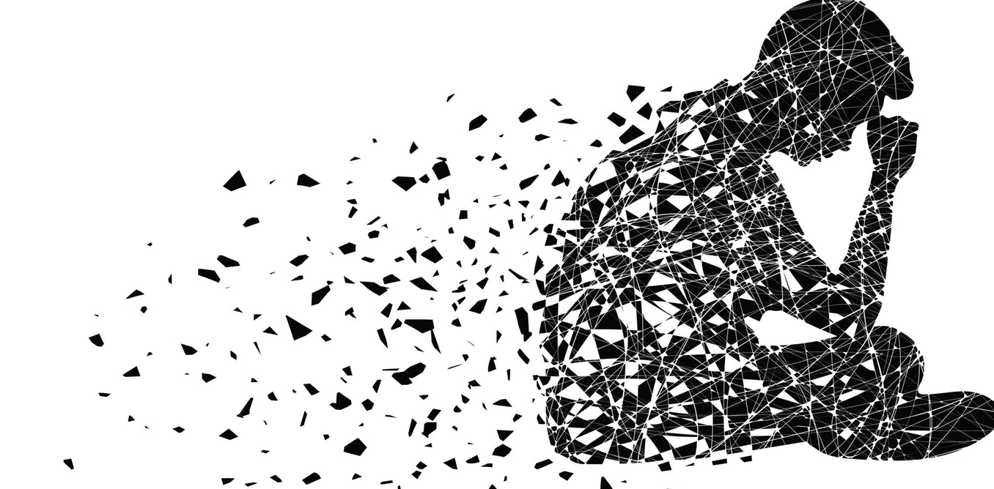  -Seek to understand the world from their vantage point.
Remember you are the parent……  Take your power back!! | IN THE MIND OF A CHILD ~ POWER = SURVIVAL  TIPS  - Parents should not engage in arguments with the child  This type of banter only diminishes the parents’ power and provides the child with more power over you.  - Do not be afraid of the outcome think what other choice does the child have?  - Consistency and discipline are key to changing behaviors  - Remember you are the parent. Trust that you are making the best decisions you can for that child  - Balance dependency and independence. Provide room for the child to be independent however remove things so the child has to be dependent upon you. How? Allow the freedom for children to do or say things the way they need to express but provide consequences for unacceptable behaviors consistently. There is a consequence for every action good or bad  - Develop the Art of tuning out - Tune out unproductive conversation  - Remain consistent with all things especially structure and discipline  - Remain calm  - Don’t take anything personal  - REMEMBER: You don’t have to respond to everything said. You don’t have to be right you’re the parent. You don’t have to have a comeback because your child has one  Remember you made it this far and are doing great. Just keep at it!!
MADD Therapy Studios
Grand Rapids, MI
Founder & Creator of MADD Therapy Studios & The Outlet
Keisha McDonald-Griffin, MA
CMHC Graduate Student
Maddtherapy@gmail.com

